EVOLVE SCHOOL SUPPORT MANUAL


PAYMENTS AND STATEMENTS
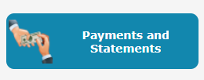

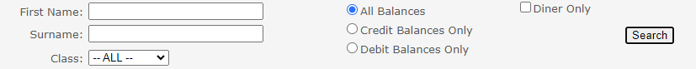
- You can search for a specific child:

- By class, or by name.

- You can also search who is in debit for reports by selecting debit balances only. The same goes for credit balances.

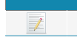
- To go into the main page, find the Diner and next to their name, select the pen and paper icon.

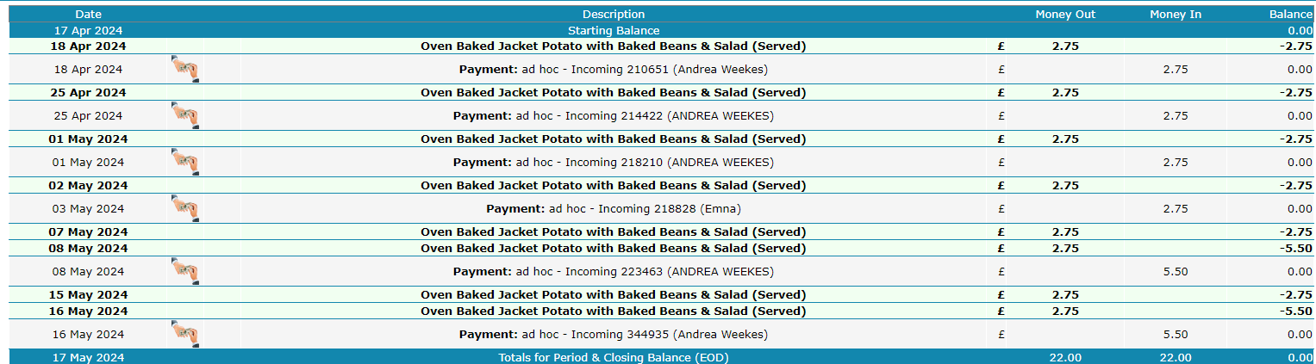
- You can check the balances and what’s been paid for.

- If a meal is served, it is in green.

- Confirmed orders in blue, these are meals not served. Parents may be in credit due to confirmed orders being paid for. If you find an account that has payment under the blue confirmed order, the parent will need to request a refund via myevolvehub.

- Try not to delete meals, if a meal has been accidentally served, you can ask one of the helpdesk or go to meals taken and unserve.

- To find all meals logged to the account, type “9999” into display last, then search.

To clear a debt:
- Select Debit Balances Only,
- Select a diner that needs to be investigated by selecting the pen and paper icon.
- Any meal that has not been paid for, will not have a payment underneath.

Marking a meal as paid:
To mark a meal as paid you can follow Cash payments document to add a cash payment. Alternatively, if there is a yellow till icon next to the meal on the pupils payments and statements page, you can use that to mark the meal as paid.

